SEMESTER TWO
Papers written by
Australian Maths Software

YEAR 11

MATHEMATICS METHODS
Units 1 & 2
REVISION 3
2016

Section One
(Calculator–free)

Name: _________________________________

Teacher: ________________________________

TIME ALLOWED FOR THIS SECTION

Reading time before commencing work: 5 minutes
Working time for section: 50 minutes

MATERIAL REQUIRED / RECOMMENDED FOR THIS SECTION

To be provided by the candidate
Standard items: pens, pencils, pencil sharpener, highlighter, eraser, ruler.

IMPORTANT NOTE TO CANDIDATES
No other items may be taken into the examination room. It is your responsibility to ensure that you do not have any unauthorised notes or other items of a non–personal nature in the examination room. If you have any unauthorised material with you, hand it to the supervisor before reading any further.

To be provided by the supervisor
Question/answer booklet for Section One.
A formula sheet which may also be used for Section Two.
Structure of this examination

 | Number of questions available | Number of questions to be answered | Working time (minutes) | Marks available | Percentage of exam
Section One  Calculator—free | 6 | 6 | 50 | 52 | 35
Section Two  Calculator—assumed | 9 | 9 | 100 | 98 | 65
Total marks |  |  |  | 150

Instructions to candidates

1. The rules for the conduct of this examination are detailed in the Information Handbook.
Sitting this examination implies that you agree to abide by these rules.

2. Write your answer in the Question/Answer booklet.

3. You must be careful to confine your responses to the specific questions asked and to
follow any instructions that are specific to a particular question.

4. Spare pages are provided at the end of this booklet. If you need to use them, indicate
in the original answer space where the answer is continued i.e. give the page number.

5. Show all your working clearly. Your working should be in sufficient detail to allow your
answers to be checked readily and for marks to be awarded for reasoning. Incorrect
answers given without supporting reasoning cannot be allocated any marks. For any
question or part question worth more than two marks, valid working or justification is
required to receive full marks. If you repeat an answer to any question, ensure that you
cancel the answer you do not wish to have marked.

6. It is recommended that you do not use pencil, except in diagrams.

7. The Formula Sheet is not to be handed in with your Question/Answer booklet.

Section One: Calculator–free 52 marks

This section has six (6) questions. Attempt all questions.
Working time: 50 minutes

Question 1 (3 marks)

Given the function graphed below, describe precisely the features of each of the labelled points.
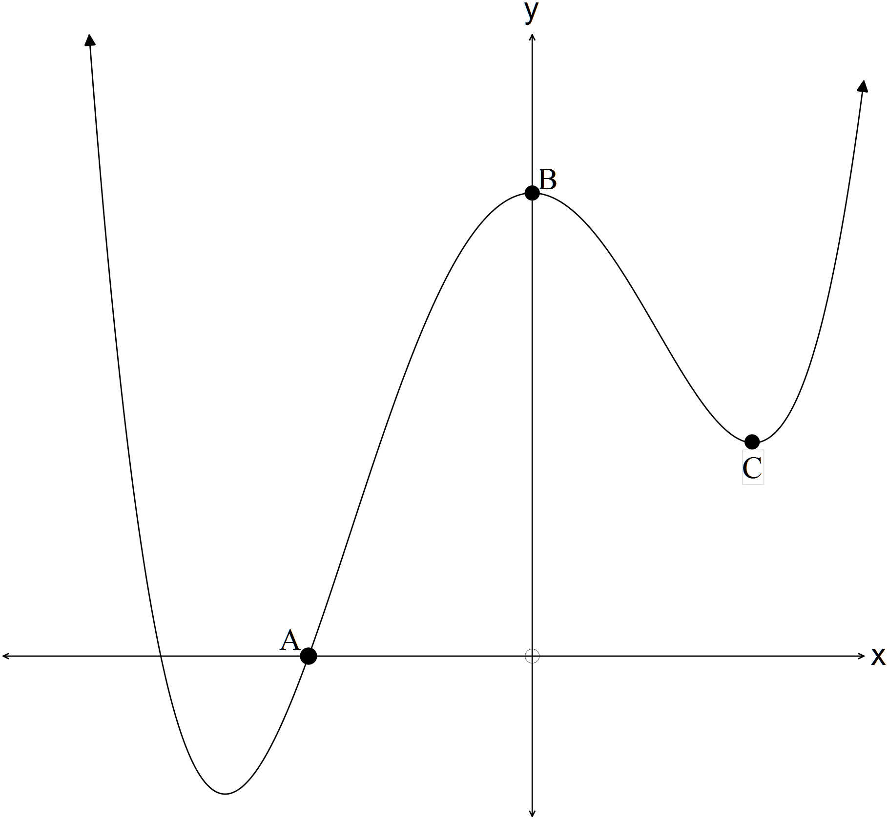

A ___________________________________________ (1)

B ___________________________________________ (1)

C ___________________________________________ (1)

Question 2 (16 marks)

(a) Simplify 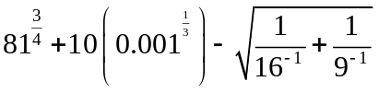 (4)

(b) Solve
(i) 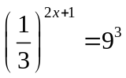 (3)

(ii) 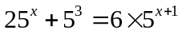 (3)

(iii) 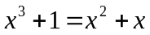 (3)

(b) If a person in pain is injected with 100 mg of a drug then the concentration () left in
the bloodstream after hours is given by 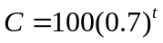.

The drug is only safe to inject every 5 hours and 100 mg is the maximum
recommended dose.

If the person has pain relief if the concentration in the bloodstream is at least 35 mg
how many hours does of pain relief does the person get? (3)

Question 3 (6 marks)

(a) Given the rule 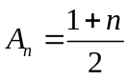, rewrite the rule recursively. (3)

(b) Given A sequence is defined as 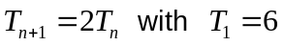,
(i) determine the first four terms. (1)

(ii) the expression in terms of . (2)

Question 4 (4 marks)

Complete the following

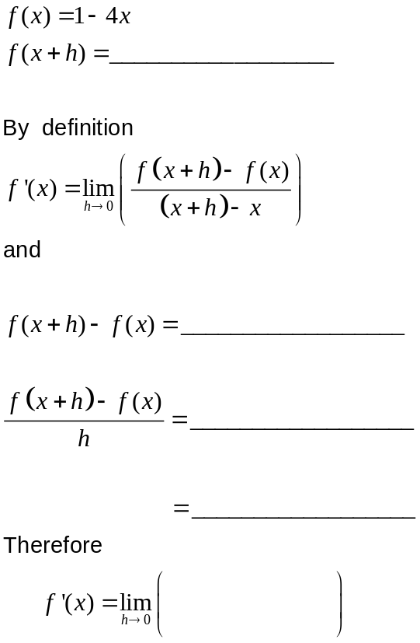

∴ 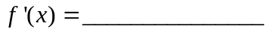
(4)

Question 5 (10 marks)

(a) (i) Graph a function that has the following properties on the set of axes below. (4)

x | -1 | 0 | 1
f | -1 | 0 | 1
f ' | + | 0 | +
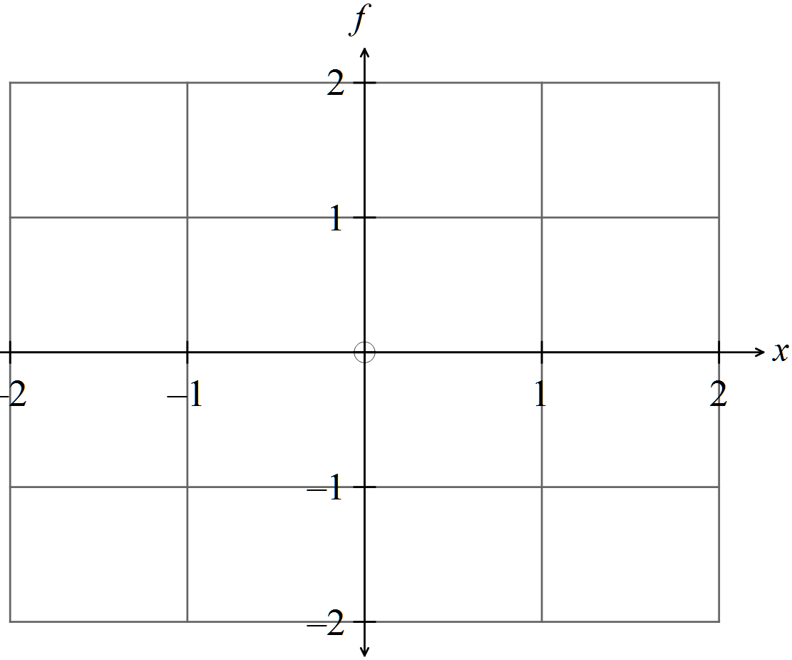

(ii) Write down the equation of the function. (2)
(b) The diagram below shows the relation 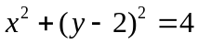

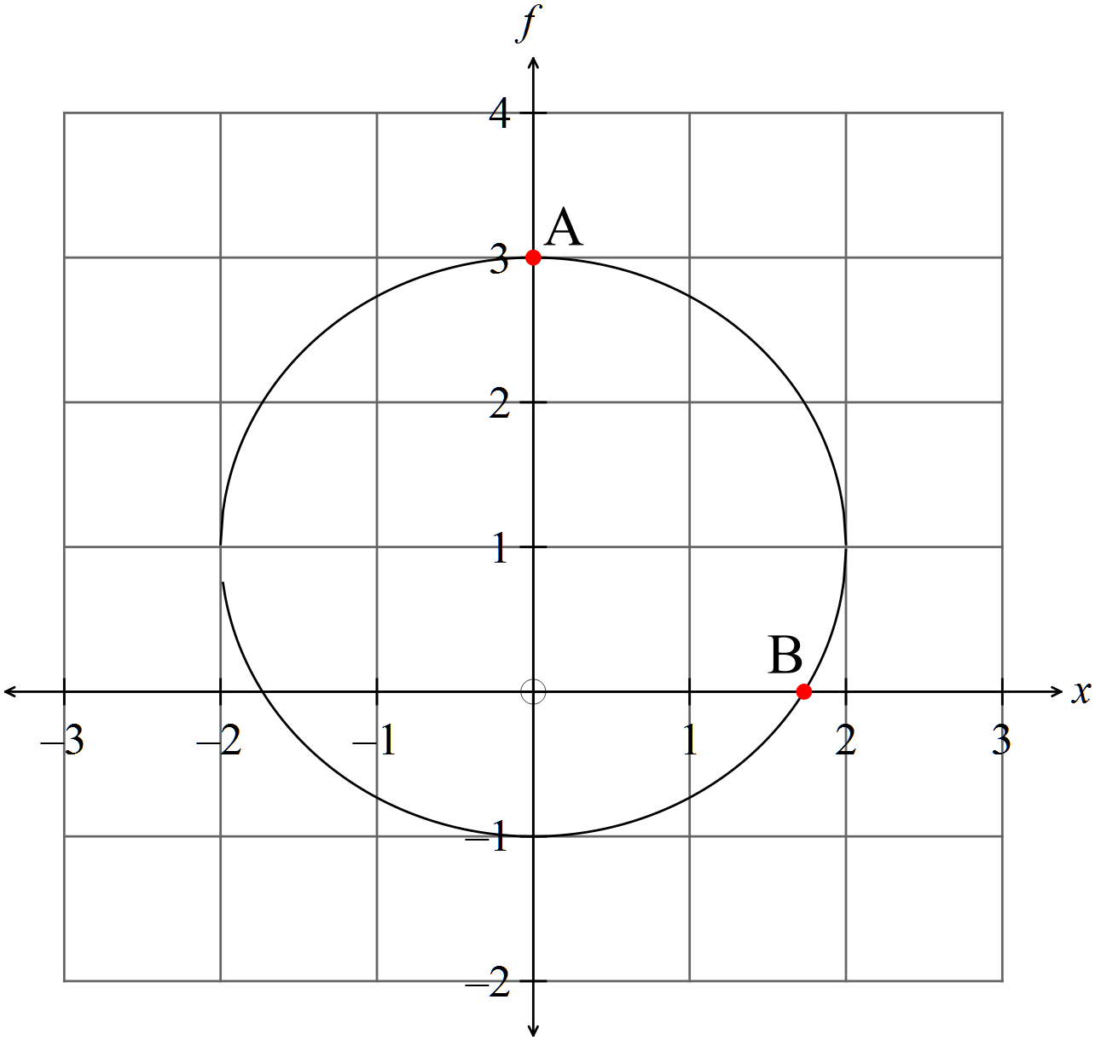

(i) Find the slope of point A and state another point with the same slope. (2)

(ii) Write down the coordinates of a point where the slope is not defined. (1)

(iii) Describe point B. (1)

Question 6 (13 marks)

(a) Determine the equation of the function graphed on the set of axes below. (3)

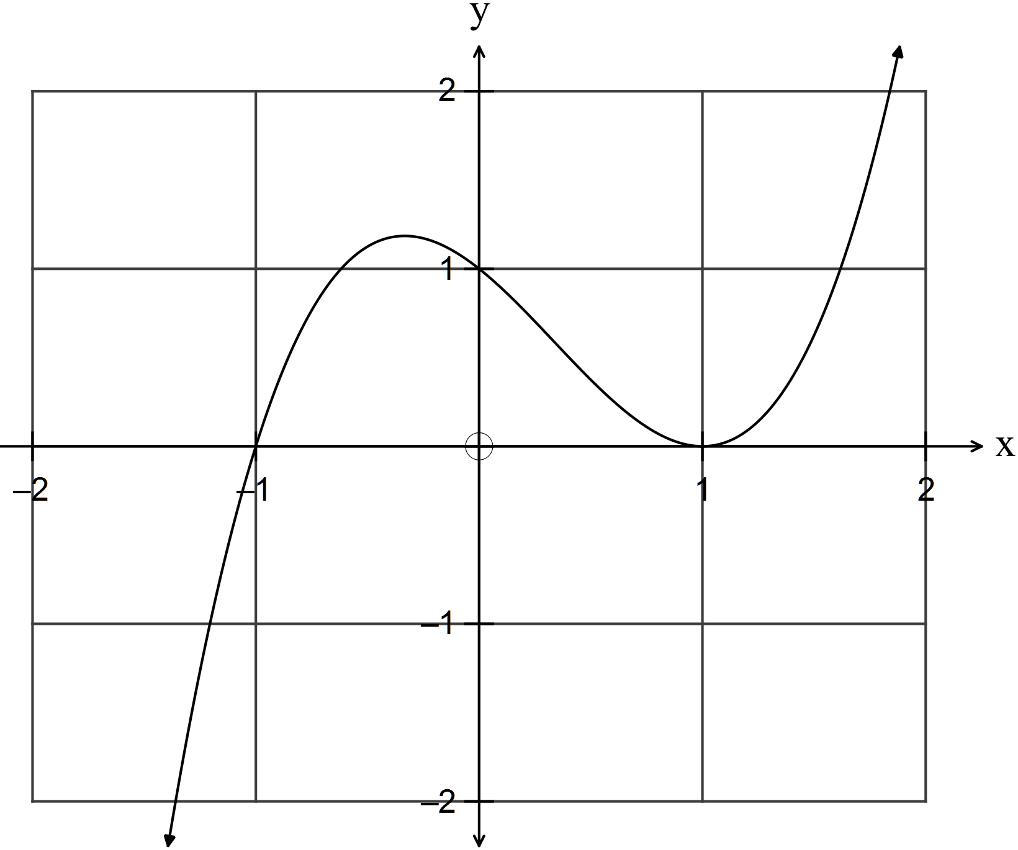
(b) On the set of axes below sketch the function 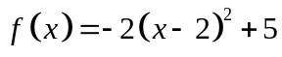 showing all intercepts. (4)

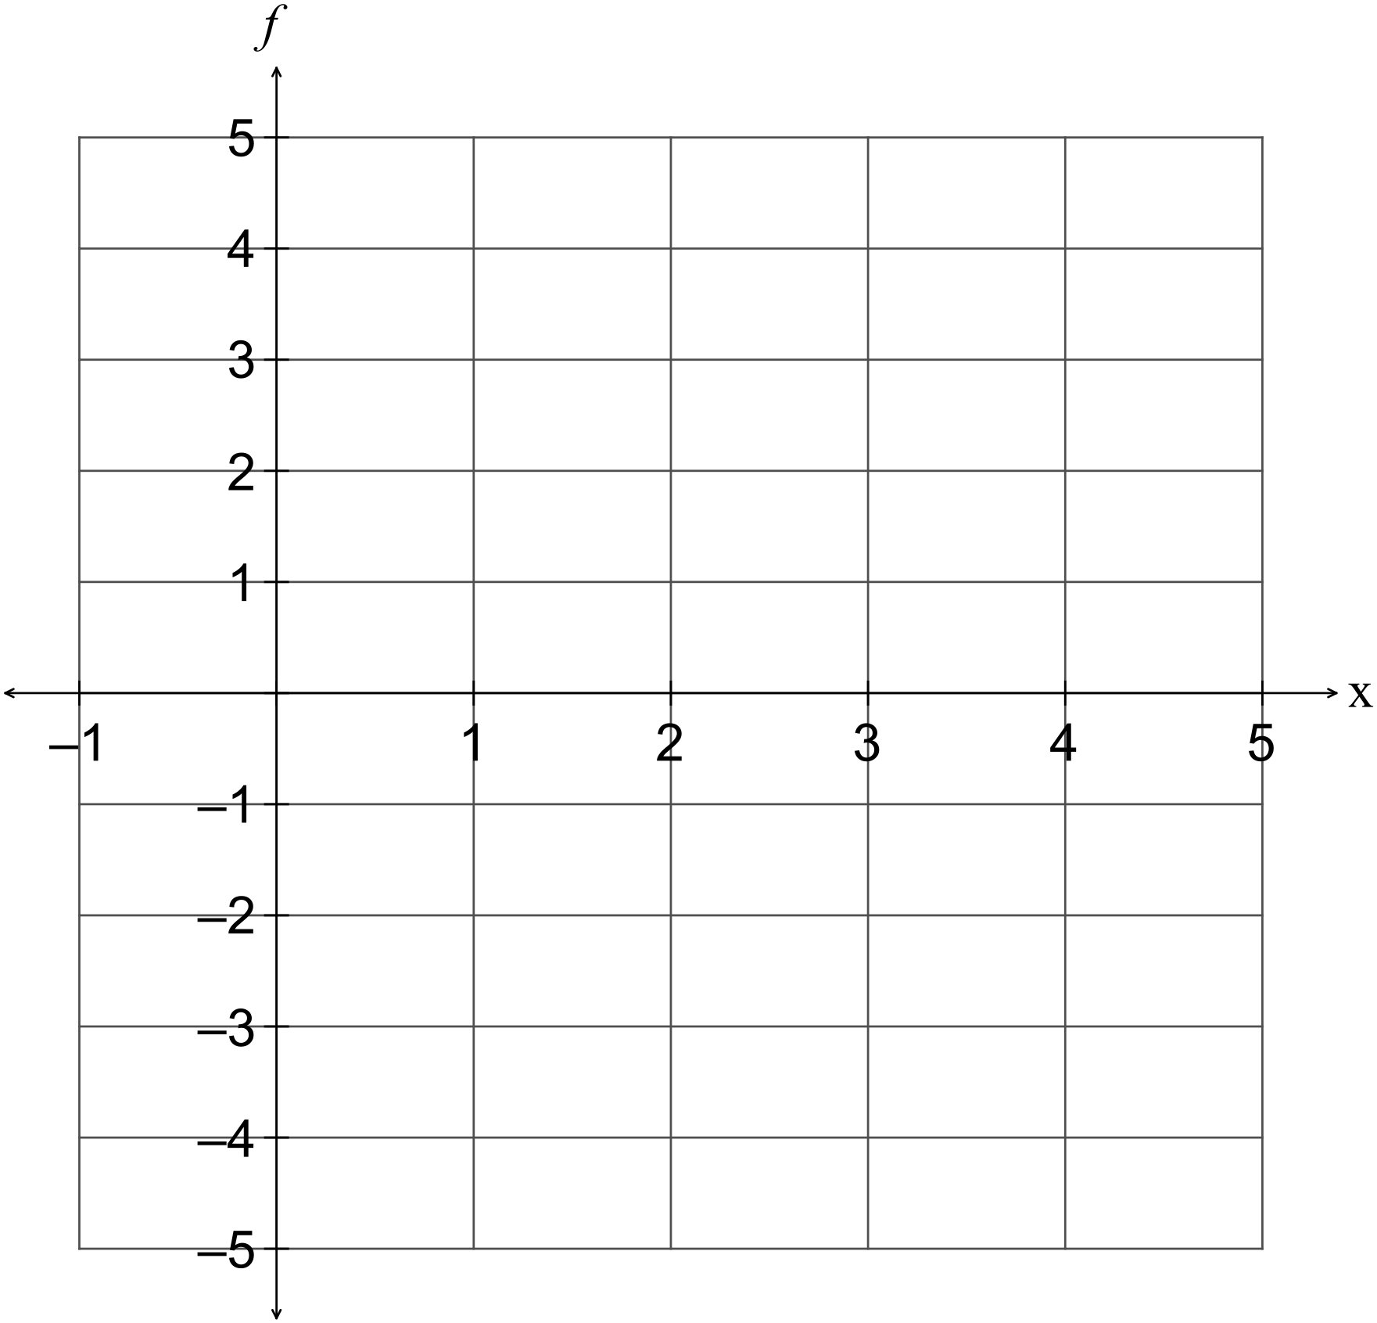

(c) On the set of axes below sketch the function 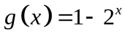 showing any intercepts. (3)

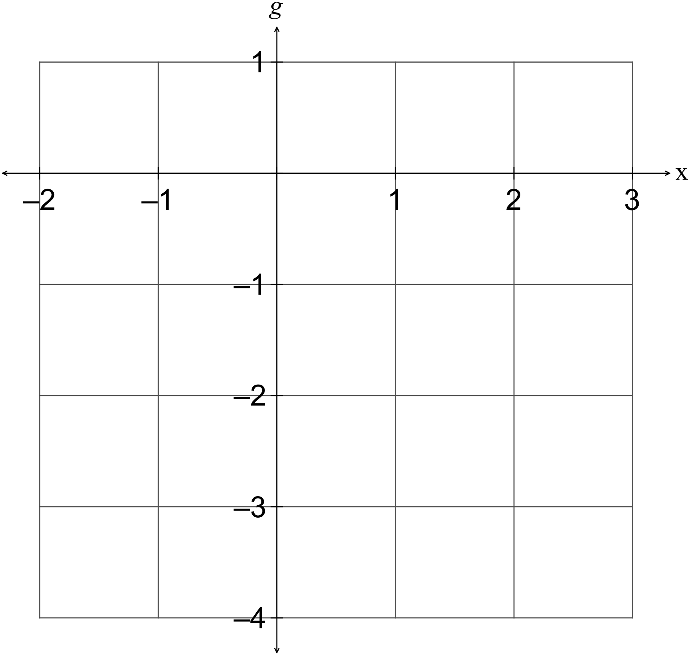

(d) Determine the equation of the function graphed on the set of axes below. (3)

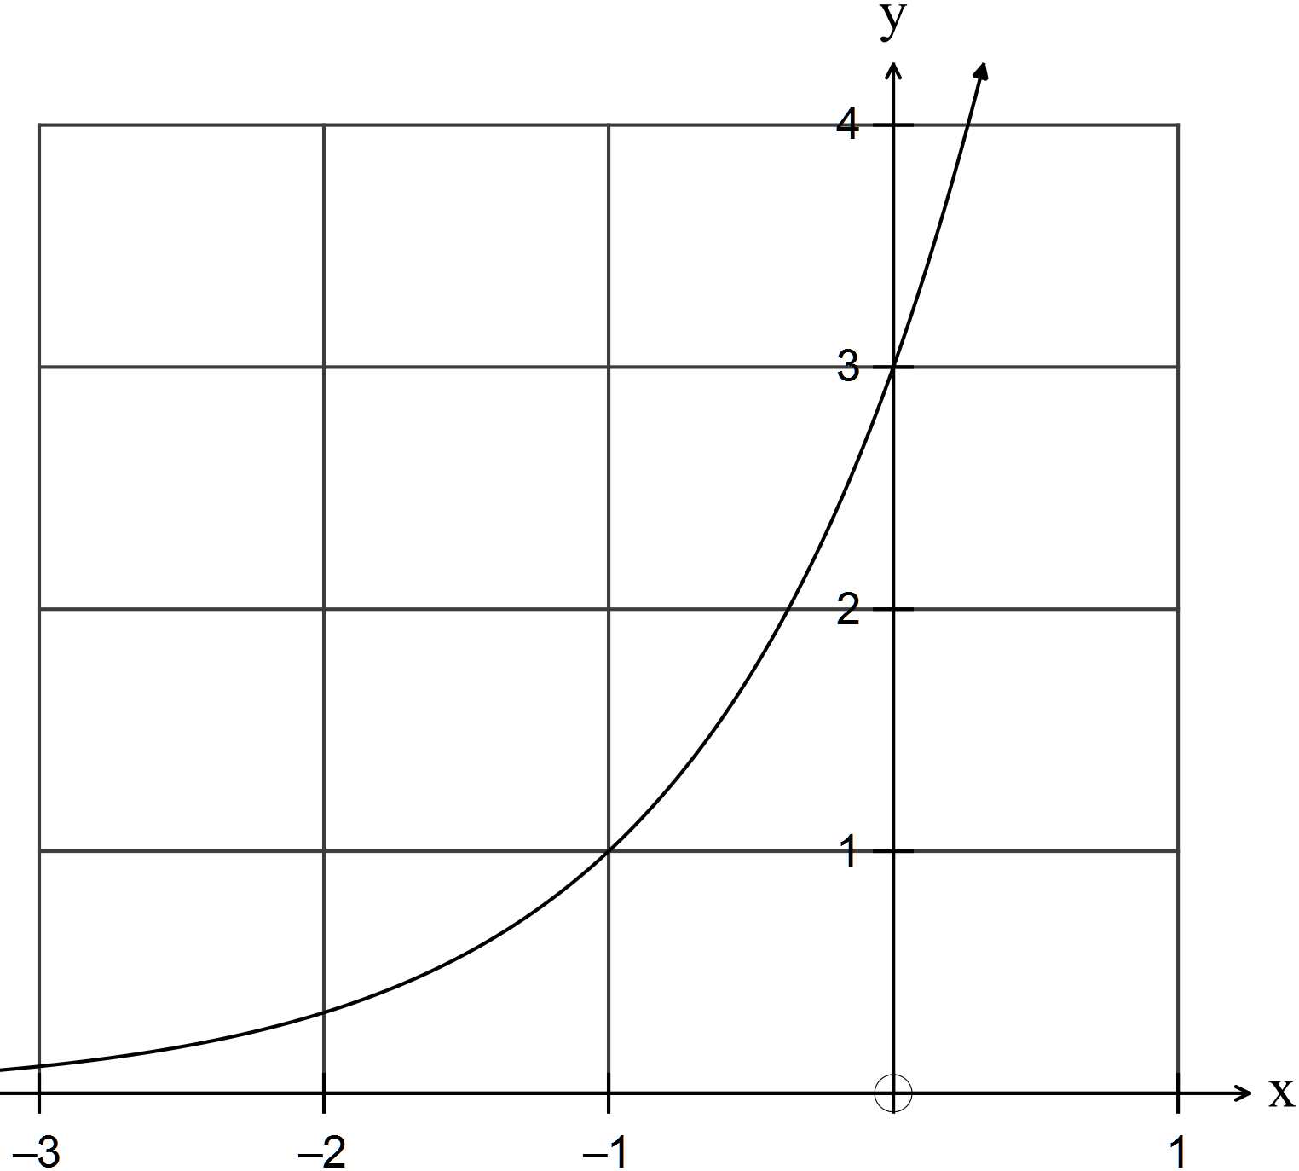

END OF SECTION ONE

